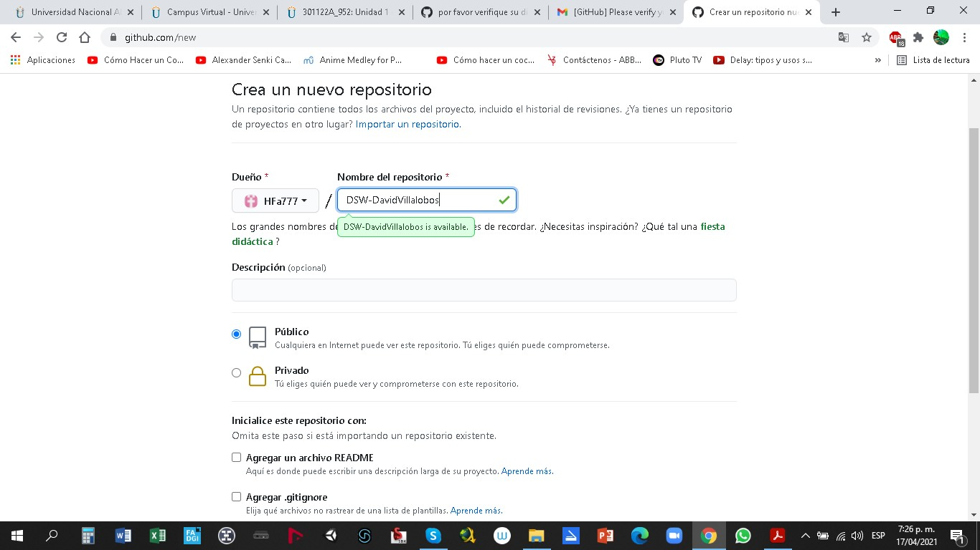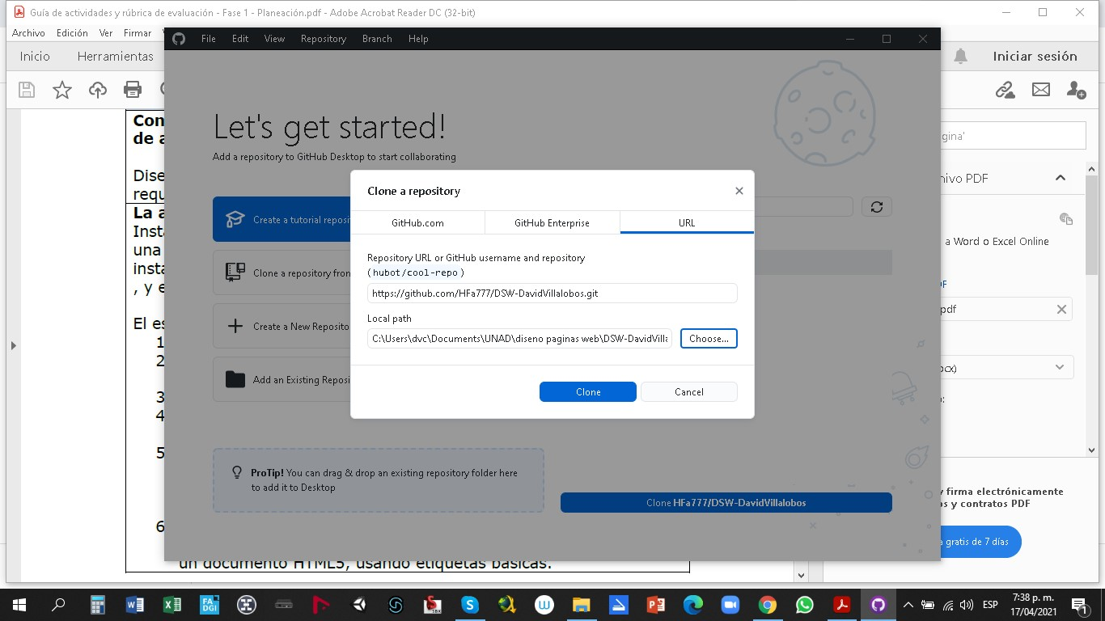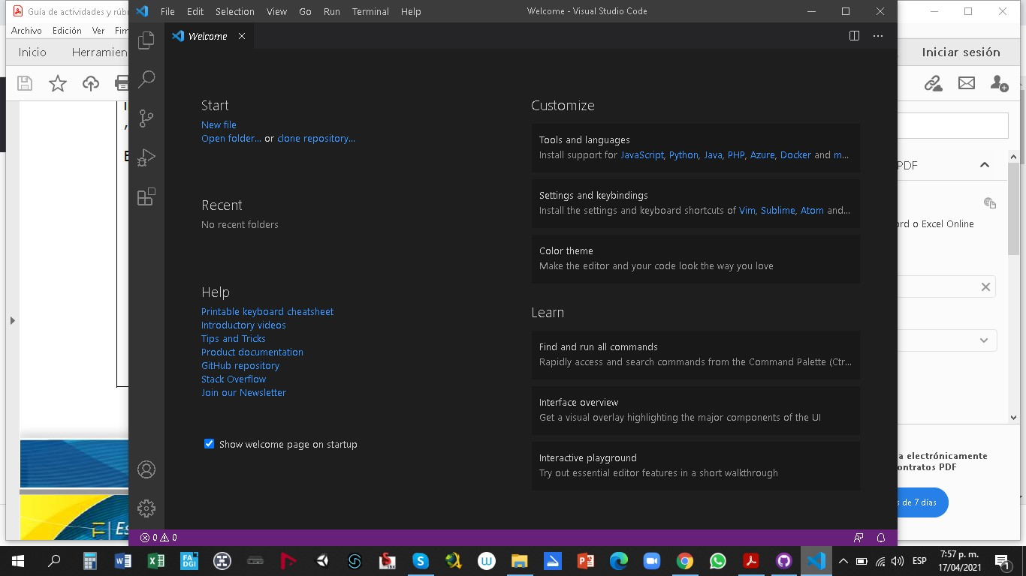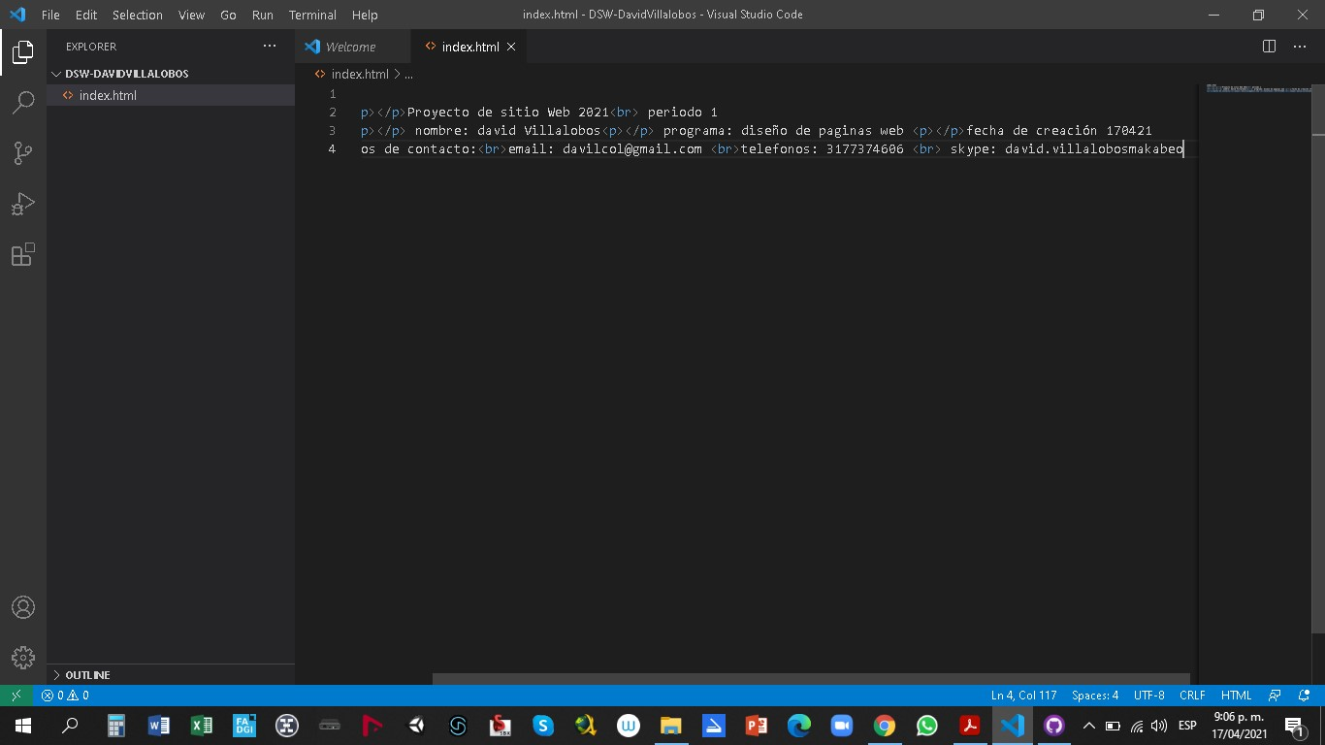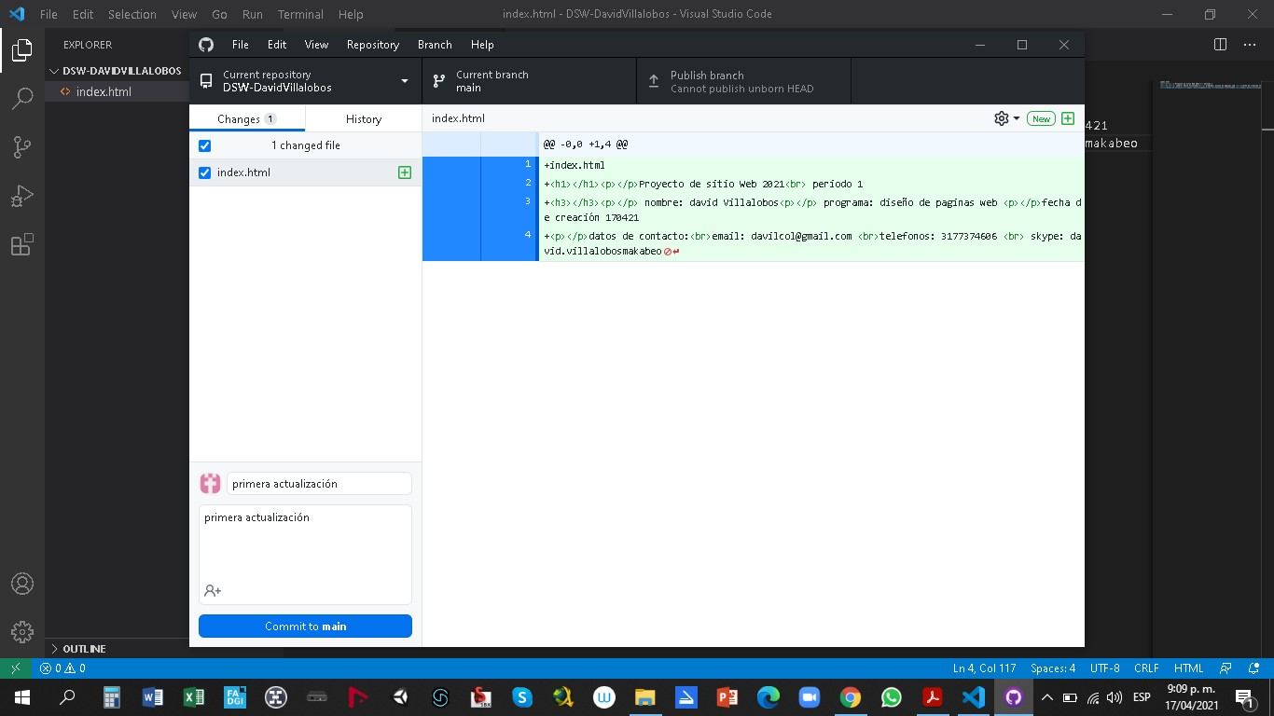

**link**

C:\Users\dvc\Documents\UNAD\diseno paginas web\DSW-DavidVillalobos\index.html

[https://github.com/HFa777/DSW-DavidVillalobos#:~:text=https%3A//github.com/HFa777/DSW-DavidVillalobos.git](https://github.com/HFa777/DSW-DavidVillalobos" \l ":~:text=https%3A//github.com/HFa777/DSW-DavidVillalobos.git)